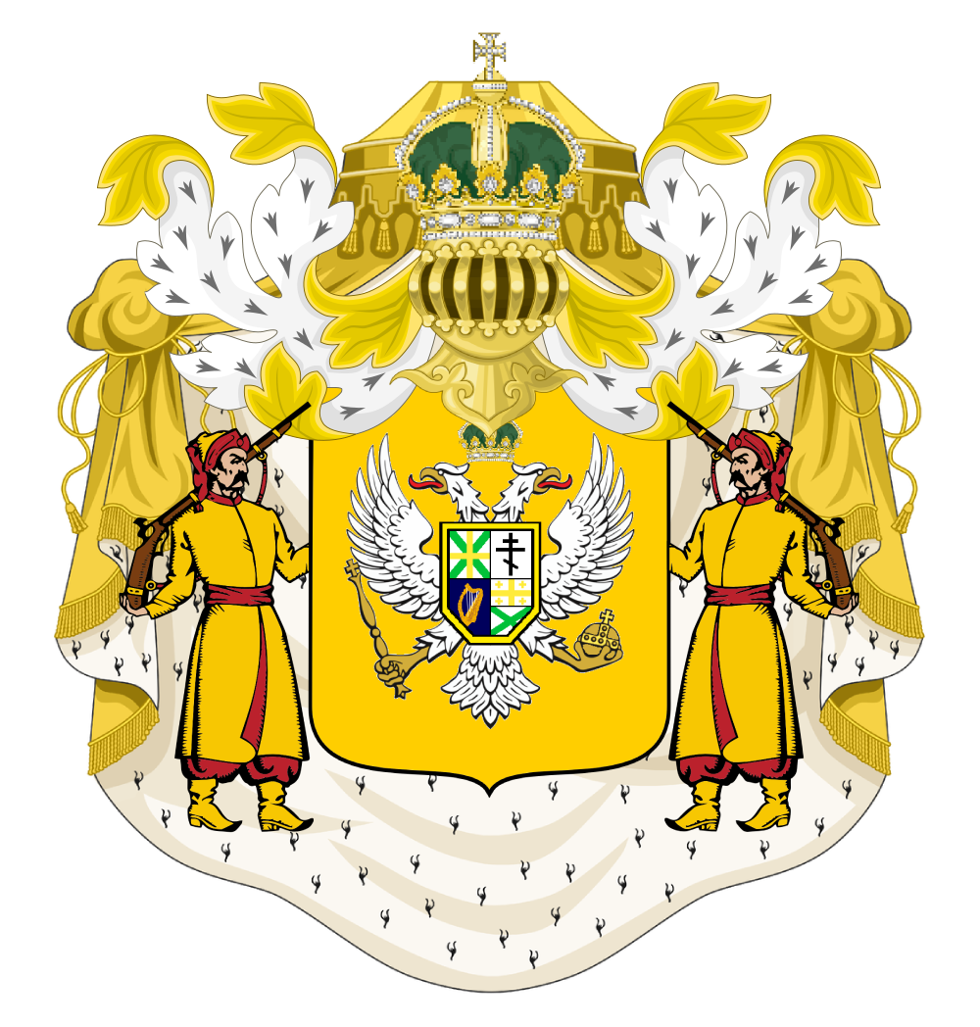

Totemia Empire
Civil Code of the Totemian Empire

Article I: Treason
Definition: Treason involves acts against the sovereign and empire, including unauthorized alliances with foreign powers.

Degrees of Treason:
- First Degree Treason (High treason)
Examples:
- Compassing the death of the sovereign, or of the sovereign’s consort, or the sovereign's eldest child and heir.
- Violating or committing adultery with the sovereign's consort, with the sovereign's eldest unmarried daughter, or with the wife of the heir to the throne
- Levying war against the sovereign in the realm
- Adhering to the sovereign's enemies, giving them aid and comfort, in the realm or elsewhere
- Desertion
- Mutiny
- Exposing the coordinates of residences, settlements, or government bases to foreigners.
- Inciting violent protests or riots.
- Leaking what the Sovereign has said to you privately.
- Destruction or desecration of the imperial standard
- Espionage.

Punishment:
Execution, Imprisonment, Exile, or Lawful Torture.

- Second Degree Treason (Petty treason)
Examples:
- Stealing from the poor.
- Destruction or desecration of the state flag.
- Destruction of foreign allies' flags by citizens.

Punishment:
Fine or Jail Time.

Article II: Murder
Definition: The unlawful killing of another individual without justification.

Degrees of Murder:
- First-Degree Murder
- Definition: Intentional and premeditated killing with malice aforethought.

Punishment:
Death (for aggravating circumstances) or life imprisonment without parole.

- Second-Degree Murder
- Definition: Intentional killing that is not premeditated.

Punishment:
Any term of years or life imprisonment without parole.

Article III: Theft
Definition: The unlawful taking of another's property.

Degrees of Theft:
- Petty Theft
- Definition: Stealing basic food and items.

Punishment:
Fine or Jail Time.

- Grand Theft
- Definition: Stealing valuable items, vehicles, or property.

Punishment:
Fine & Imprisonment.

Article IV: Property Damage
Definition: Intentional destruction or defacement of property.

Examples:
- Vandalism, graffiti, or defacing public or private property.

Punishment:
- General: Fine or Community Service.
- Severe/Repeated Offenses: Additional penalties at His Imperial Majesty’s pleasure.

Article V: Assault and Violence
Definition: Any form of unprovoked violence or harassment.

Examples:
- Physical attacks, verbal abuse, or harassment.

Punishment:
- Minor Offenses: Community Service or Jail Time.
- Severe Cases: Exile or imprisonment.

Article VI: Environmental Conservation
Definition: Protection of the environment and natural resources is a national duty.

Examples of Offenses:
- Deforestation, over-mining, or harming the environment.

Punishment:
- General Offenses: Fines or Forced Reforestation.
- Severe Offenses: Imprisonment.

Article VII: Freedom of Speech
Definition: Citizens have the right to express their opinions freely, with limitations.

Limitations:
- Hate speech, discrimination, or incitement to violence are not protected.
- General harassment is prohibited
- Speech defacing, disrespecting, or slandering the sovereign and or his family will be considered treacherous and will be treated as under first degree treason.

Punishment:
- General Offenses: Warning, Fine, or Temporary Suspension of speech privileges.

Article VIII: Trade Regulations
Definition: Fair conduct in trade and commerce is required.

Prohibited Practices:
- Price gouging, monopolies, or deceptive trade practices.

Punishment:
- Offenses: Fines, Confiscation of illicit gains, or Temporary or Permanent Ban from trade.

Article IX: Citizen Duties
Definition: Citizens are expected to participate in community growth and uphold laws.

Punishment for Non-compliance:
- Fines, Forced Civic Engagement, or Temporary Suspension of privileges.

Article X: Impersonation
Definition: Impersonation of officials, military, or imperial/royal persons is prohibited.

Punishment:
- At His Imperial Majesty's Pleasure.

Article XI: Imperial Property and Armed Groups
Definition: Regulations regarding government property and the formation of armed groups.

Prohibitions:
- Trespassing on Imperial Property: Any crimes on government property will be considered treason.
- No Private Armed Groups: 3 days in jail for all members.
- No Military Units Without Permission: 5 days in jail for all members.
- No Company or Business Militia: 7 days in jail.

Article XII: Offenses Against Military Personnel
- Murder Without a Duel Accepted: 1 day in jail.
- Use of Deadly Force Against Military Personnel: 4 days in jail.
- Harassment of Military Members: 1 day in jail.

Article XIII: Legal Conduct
- Contempt of Court: 5 days in jail.
- Extortion: 1 week in jail.
- No Use of Force Against Unarmed Individuals: 5 days in jail.
- Desecration of National Symbols: 1 week in jail.
- Corruption: 1 week in jail.

Article XIV: Sexual Conduct
Definition: Regulations regarding sexual relationships and consent.

Laws:
- Age of Consent: 19 years old (Lenskov Calendar Years).
- Consent for Minors (13-15 IRL): Can only consent to sexual acts with someone 4 years older. Violators face 2 weeks in jail.
- Power Imbalances in Relationships: 2 weeks in jail.
- Age Fraud in Relationships: 2 weeks in jail for misrepresenting age.

Punishment for Violations:
- Rape, Sexual assault, or Sexual Misconduct: 8 days in jail or exile + Watchlist.
- Sexual Harassment: 4 days in jail or exile + Watchlist.
- Interference Based on Relationship Status or Identity: 7 days in jail.

Article XV: Serious Offenses
Punishment for Severe Crimes:
- Conspiracy to Doxx: 14 days in prison without bail or exile
- Doxxing or leaking info in any way, Exile or death
- Conspiracy to Commit Assassination: 10 days in jail or exile.
- Attempted Assassination: 20 days in jail or exile.
- Assassination of a High-Profile Target: 28 days in jail or death.
- Threats Against Players or Server: 15 days in jail or ban.
- Conspiracy to Coup: 60 days in jail.
- Attempted Coup: 80 days imprisonment, possible exile, or death.
- Destruction of State Symbols: 2 weeks in jail.

Article XVI: Miscellaneous Offenses
Punishment for Common Sense Violations:
- Trespassing: 1 day in jail.
- Murder of Pets: 1 day in jail per pet killed.
- Public Indecency: 3 days in jail.
- Identity Theft: 4 days in jail.
- Bribery: 1 week in jail.
- Slander/Libel: 1 week in jail.
- Vandalism: 1 day in jail.
- Advertising servers and other things: 3 days in jail

Article XVII: Bail and Legal Proceedings
Definition: Bail will be available for petty crimes based on the response of law enforcement or a judge/magistrate
- Default Bail: 10,000 shillengs.

Article XVIII: Arms without registration
To legally own a firearm, you must go through an appointed official, a military officer, or directly to me

Punishment:
3 days in Jail

Article XIX: Currency Forfeiture
Definition: Currency forfeiture is the lawful taking and permanent forfeiture of Totemic currency held by a person.

Scope: Currency forfeiture applies only to Totemic currency. It does not include goods, crops, materials, tools, buildings, land, equipment, labor, or any other non-currency property unless separately authorized by law.

Authority: Currency forfeiture may be carried out by the Treasury of the Totemian Empire or by officials delegated to act on behalf of the Emperor.

Use: Currency forfeiture may be used against persons found guilty of treason, persons whose lawful punishment includes exile or execution, or citizens who have left Totemia for more than seven days, have left the Discord server, and have purposely severed communication with Totemia.

Exception: Currency forfeiture shall not apply to persons absent due to a kick, temporary ban, time-limited punishment, technical issue, or any absence not intended as a permanent departure from Totemia.

Discretion: Currency forfeiture is discretionary and shall not be required in every eligible case. It may be used in addition to any other lawful punishment.

